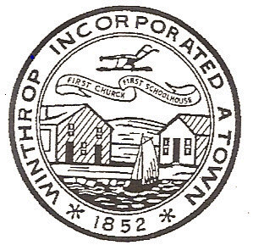

Town Council Meeting Minutes

December 16, 2008
Under the Rules and Procedures of the Winthrop Town Council, President Reilly called the meeting to order at 7:00 PM in the Joseph Harvey Hearing Room. Councilor Maggio, Councilor Calla, Councilor Ferrino, Councilor Gill, Councilor Letterie, Councilor DelVento, Councilor Sanford, Vice President Boncore and President Reilly were present.

Joint Meeting with the Board of Assessors for the Tax Classification Public Hearing

Board of Assessors Present were Mr. Donohue, Mr. Maruzzi and Deputy Assessor Patrick Harring were present.

Public Comment

Dave Osborne, Todd Sacco, Erik Gaynor, Gus Martucci and Guy Brandenstein participated in public comment.

MOTION:by Vice President Boncore
2nd by Councilor Gill

VOTED: to adopt a Residential Factor of 1.0 maintaining a single tax rate for Residential and Commercial, Industrial, Personal Property.

Councilors Letterie & Sanford asked that the record show they both abstained from voting.

Public Comment

Erik Gaynor, Guy Brandenstein, Gerry DiFranza and Lee Dzedulionis participated in public comment.

VOTED: this was the conclusion of the joint meeting at approximately 7:20pm.

Correspondence

PUBLIC COMMENT

COMMITTEE REPORTS

TOWN MANAGER’S REPORT

OLD BUSINESS

MOTION:by Councilor Letterie
2nd by Vice President Boncore

VOTED:

MOTION:by Councilor DelVento
2nd by Councilor Letterie

VOTED:
NEW BUSINESS

PUBLIC COMMENT

There was no public comment.

MOTION:by Vice President Boncore
VOTED: to adjourn for the evening at 10:30PM.

Respectfully Submitted,

Carla Vitale

